**Index page:**

**In full screen:**

1. Unsymmetrical every right side - all pages have this problem everywhere of title next to content in a similar way.

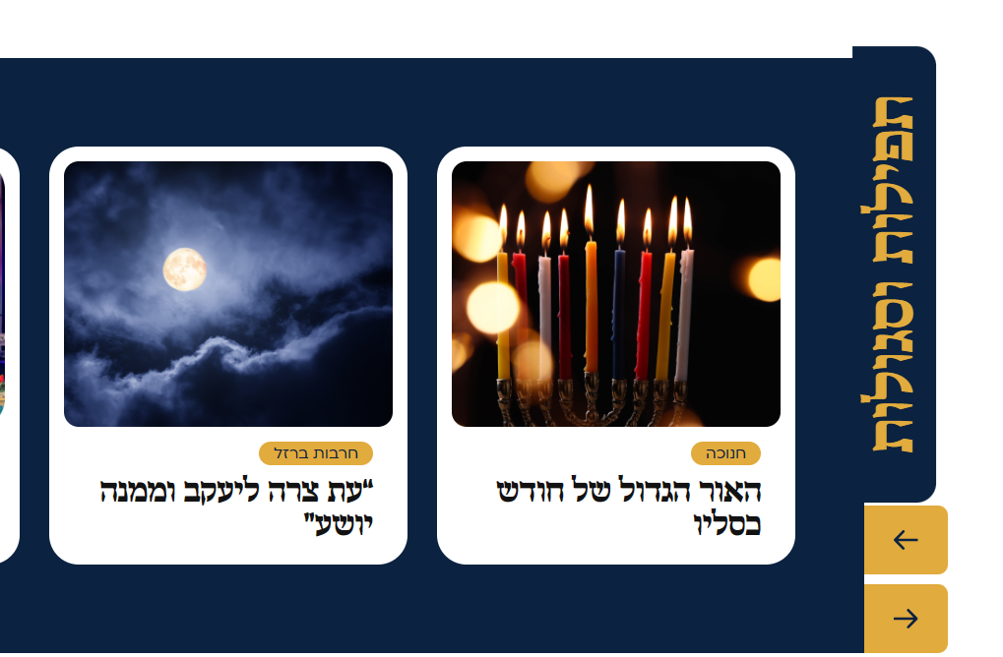

1. In some of the small sizes on the DESKTOP screen, the responsiveness does not seem correct so that the elements on the sides exceed the body of the page And in the footer the columns connect a little.
2. In the NAVBAR above, when you go through the search, it opens it and disappears if you move it, it's hard to type. When clicking on the search, the input should stand and not close again



1. On a laptop screen (slightly smaller) - the elements overlap each other when scrolling the page



**Mobile screen:**

1. Title is too big, you can't see it



1. Subheadings are too big



1. The buttons should not float, and the times of the day and the advertisement on the left side should be removed
2. When you scroll to the sides with precious pearls and so on - it scrolls the whole screen together
3. In this section and others like it - all the texts and buttons are not coded according to the figma, and you need to be centered on the right side



1. Mobile does not have this part

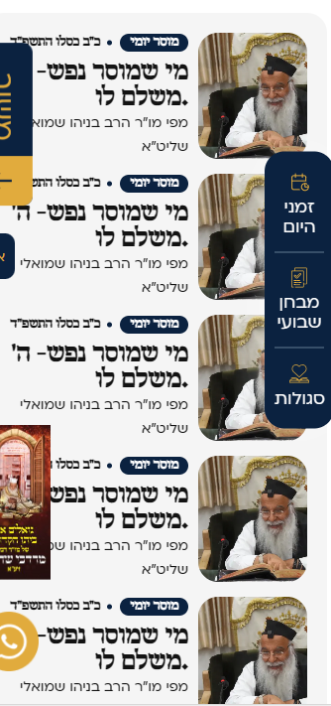

1. The title "תפילות וסגולות" disappears, asymmetric buttons, as well as in mobiles, one whole cube will be shown according to the screen size, it is cut off..

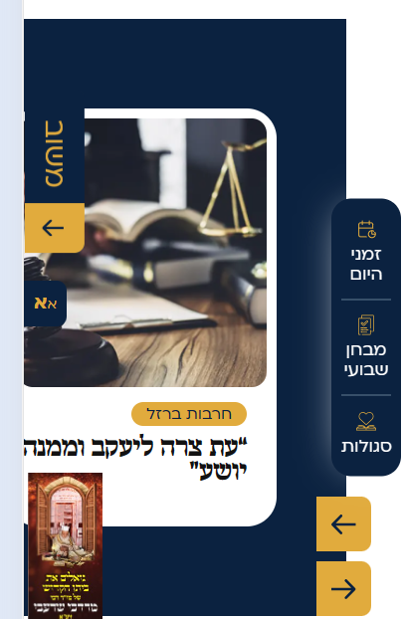

1. This part is designed in different colors and the button sizes are incorrect

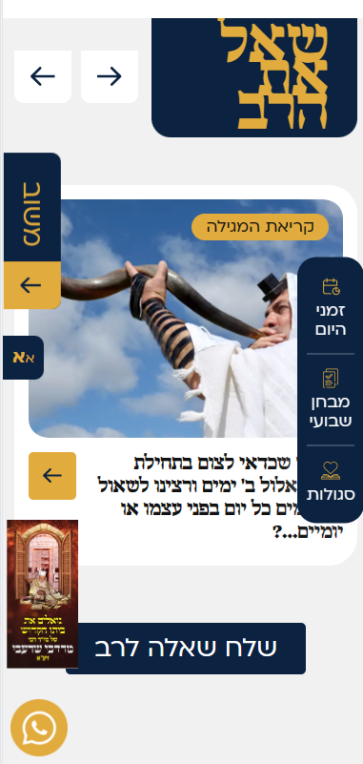

1. Each gallery should have an addition like there is in the transition in full screen

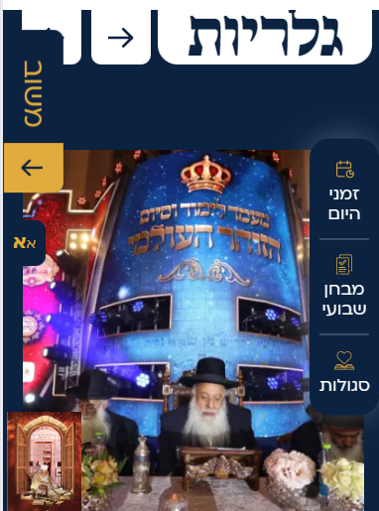

1. designed differently



1. Asymmetric button



1. A higher place for the message and a wider button, not accurate for figma

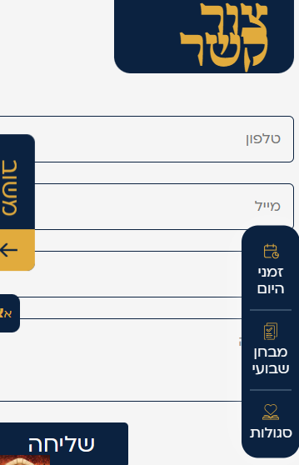

1. A smaller logo and all content should be divided into 2 columns and not one long column and mobile's FOOTER has a normal design for all texts without highlights

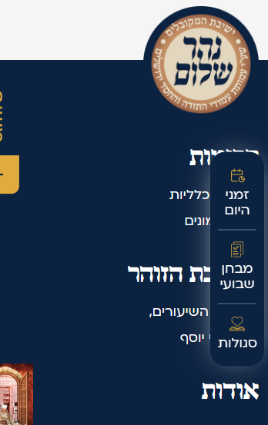

1. The size of the questionnaire panel should remain the same size, the size changes from screen to screen according to the content

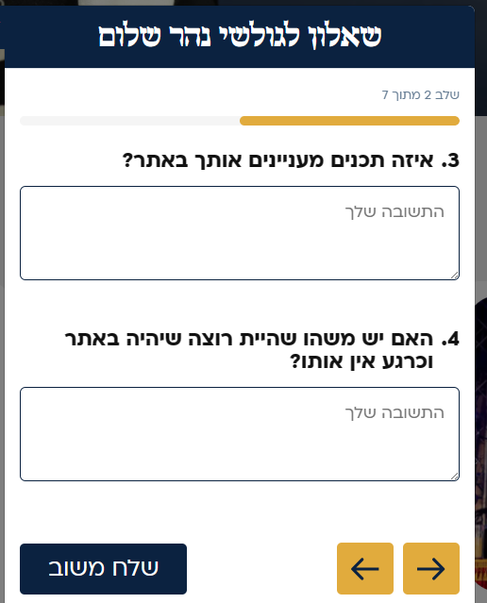

**Blog page:**

1. לא סימטרי



**Internal-donation page:**

1. A font that is too large must be entered on the same line



**Qna page:**

1. The icon is on the other side and lacks sentence formatting when there are no matches



1. The boxes are small according to the contents. They should always be the same size and if the text is too long - cut it after X lines



1. Too wide and should float in the page scroll

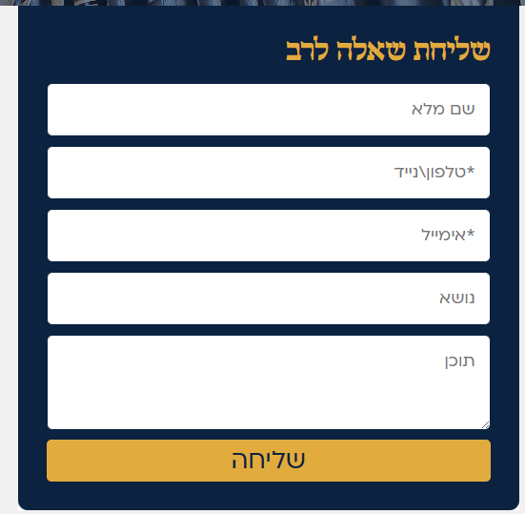

**Stringing-page page:**

1. When moving over the text the color changes



1. Many pages also lack the advertisements and the times of day on the sides, perhaps the body of the page should be reduced a little more so that it can fit in there and remain open like in the FIGMA design

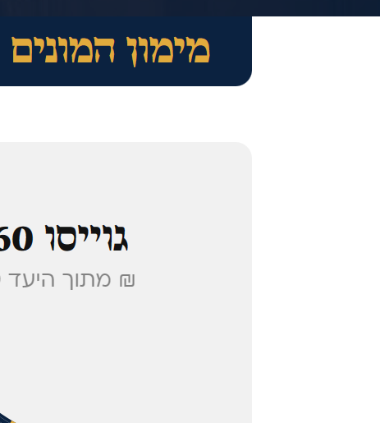

1. Texts are more subtle and not so bold

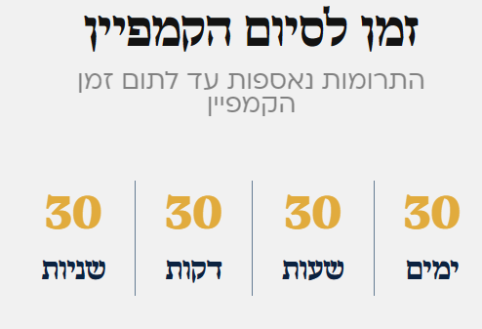

1. Missing V marking on marked filter

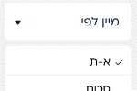

**Vartue_prayars page:**

1. The height of the boxes varies according to the length of the text, it should be uniform and the text should be cut if it is too long, as well as the boxes are connected to each other

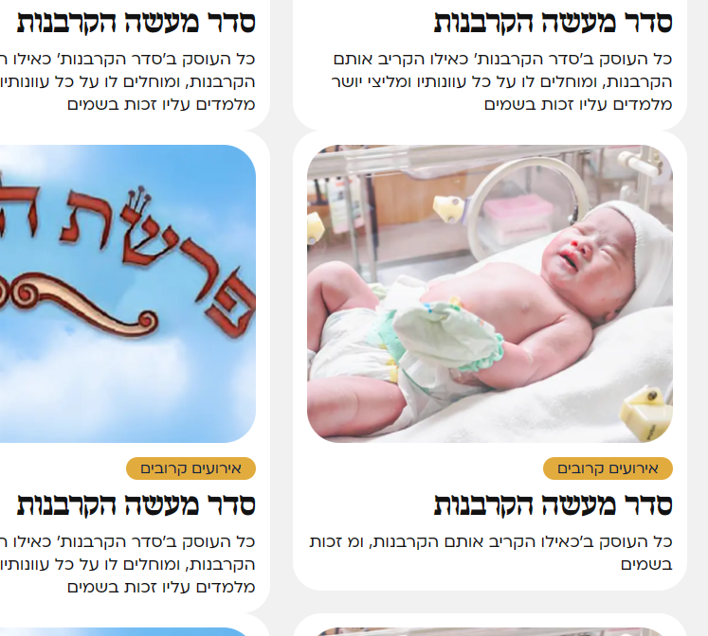

1. As above, the length of the title should also be limited to a maximum of 2 lines, perhaps

**Blog-details page:**

1. The text "fancy donation" is out of place



1. The box is too wide

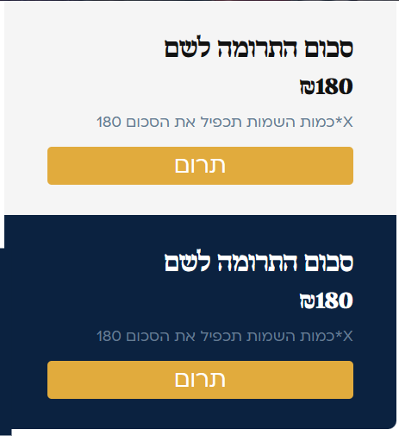

**Campaigns page:**

1. Introducing the option of filling a frame by percentage



Classes page:

1. Lack of advertisements on the sides of the page, the margins should be increased
2. Buttons should be smaller

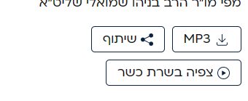

**Faq page:**

1. The box is too wide

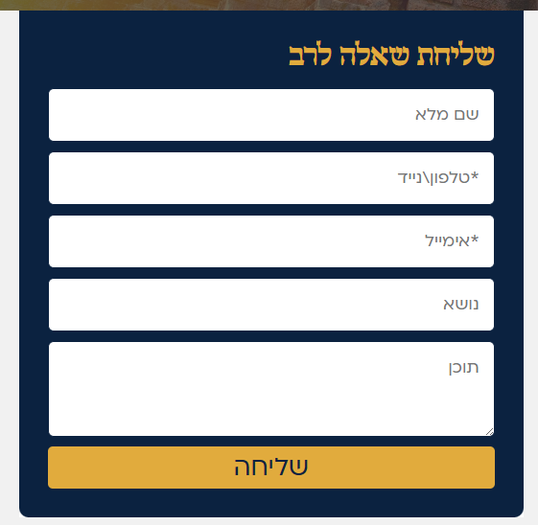

**Gallery page:**

1. Asymmetric button



1. Missing attachment of a suitable icon in any case



**Gallery2 page:**

1. This part is missing when moving over an image within a gallery

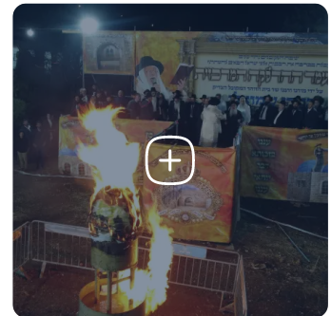

In this place there is this, what is it supposed to do? I don't see it in figma



**Gallery3 page (Alonim):**

1. Boxes are too big, on a large screen 4 should fit in a row and buttons are too big, more should fit in a row

